NORTH WESTERN UNIVERSITY



Report

Course Code: CSE-2104

Course Title: Data structures laboratory

Special Thanks to:

Md. Shymon Islam

Lecturer

Department Of CSE

North Western University

Khulna, Bangladesh

Developed by:

Nayon Debnath Student Id: 20221031010

Shanto Biswas Hrithik

Student Id:20221010010

Mimma Mawa Student Id:20221016010

Department Of CSE

North Western University

Khulna, Bangladesh

***Table of Contents***

*1.Introduction……………………………………………………….*

2.Objectives...............................................................................

3. Description…………………………………………………….…

4. Dependencies:………………………………………………..

**1.Introduction**

On this project we working a python language base project. This is data structure base project that include array and linked list for creating a graphical user interface(GUI) we using the Tkinter library.

* An array is a base of data structure that stores a fixed-size of element and same type of data in contiguous memory locations.
* A linked list is a base of data structure that stores sequence of nodes.Node contain a value and a reference link to the next node in the sequence.

**2.Objectives**

The project base on basic data structure operations such as insertion, deletion, searching, and updating elements in both arrays and linked lists.

**Class and Method overview**

Class Node

func_init_

class LinkedList

func_init_

func add_begin

func add_end

func add_after_x

func add_before_x

func delete_node

func delete_begin

func delete_end

func search_element

func update_element

func display_list

class nayon

func _init_

func play_sound

func home_interface

func array_interface

func create_array

func array_interface_2

func show_array

func array_insert

func insert_interface

func array_delete

func delete_by_index

func delete_by_index_interface

func delete_by_value

func delete_by_value_interface

func array_search

func search_interface

func array_update

func update_interface

func linkedlist

func add_begin

func add_end

func add_after_x

func add_before_x

func delete_node

func delete_begin

func delete_end

func search_element

func update_element

func display_list

func clear_placeholder

func set_placeholder

func button_click

func clear_entries

const

root

const

app

**3.Description**

1.import all the necessary modules including messagebox, tkinter.

2.Than we define two classes: nayon and linkedlist.

3.**Nayon class**: Each of note have two part data and another node memory address.

4.**Linkedlist class:** Base on data structure we implements the linkedlist.We work for adding nodes at the beginning or end, adding nodes after or before a specific node, deleting nodes, searching and updating elements,and display the linkedlist.

**Home page:**

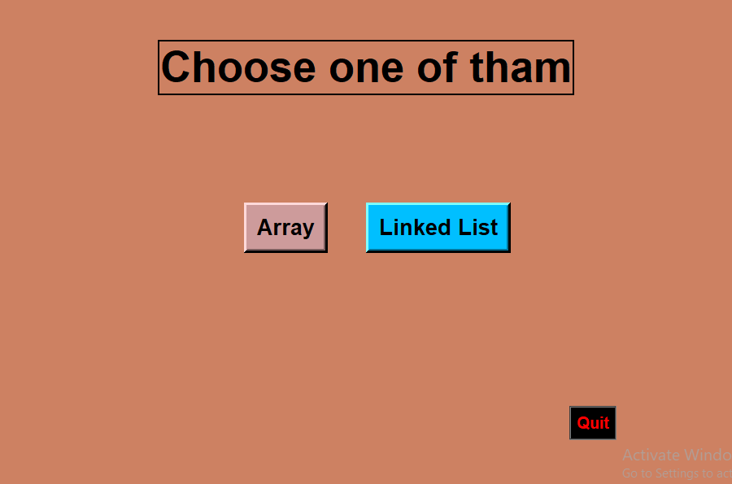

This is home page of data structure project.Here is the two buttons first array and second linked list and down-right corner have a Quit buttons.We give the user two option Array and Linked list he/she chosse any of tham.

**Array:** when user click array button than come to option and user give the input the size of array.

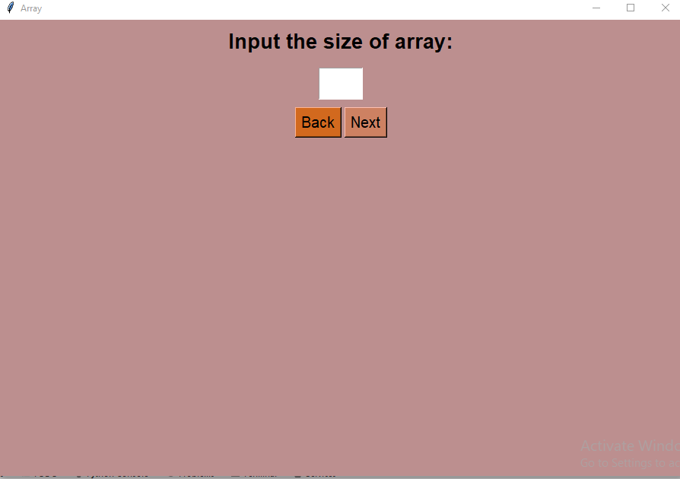

Than input a size of array than we click the next button and than we give right to choose random number to input as a array elements

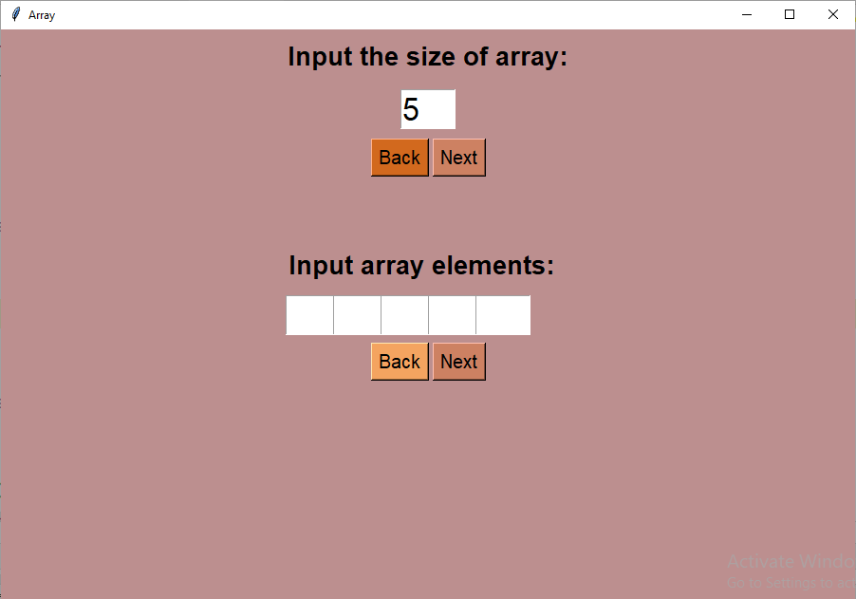

Array operation:

Than we work with array operation here user insert a random number,delete a number search a number and update a number.What the value you want to insert that particular index.

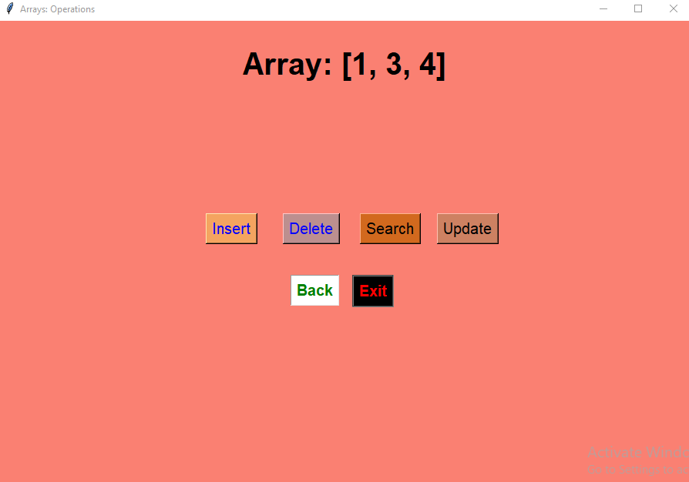

**Insertion:** The first operation of array is insert.You can insert a value at any index.So you have a input the value and the index number.what value you want to insert that particular index.

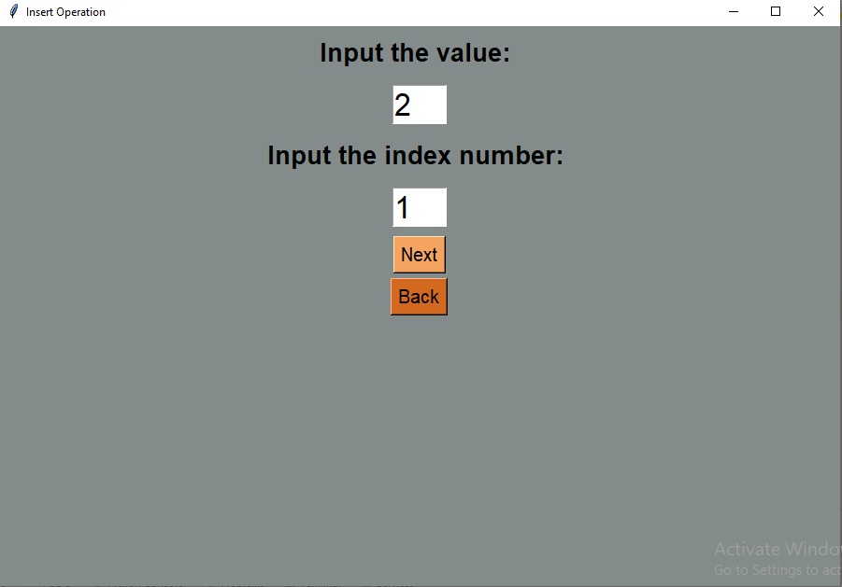

***Delation:*** Deletion operation help to delete an element by index and by value.

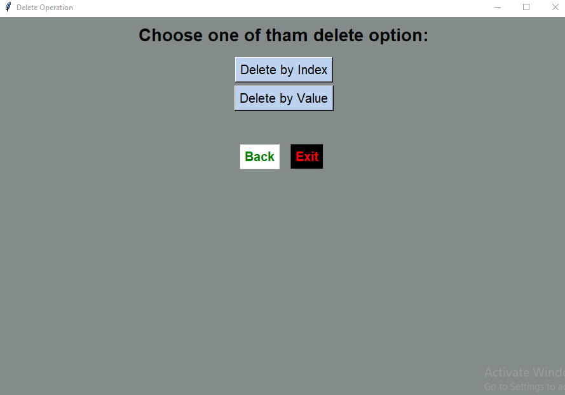

**Search element:**Input the element and see that element present are not persent in your array.

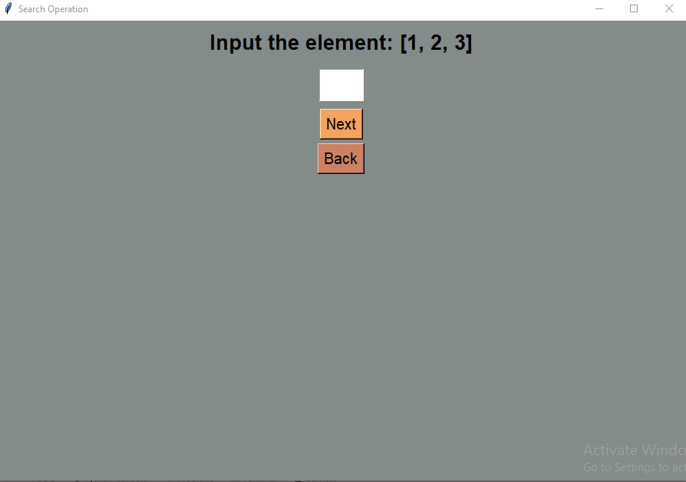

**Update element:Input the index of the value that you want to update and the second box input the value that you want to update and than hit the next button.**

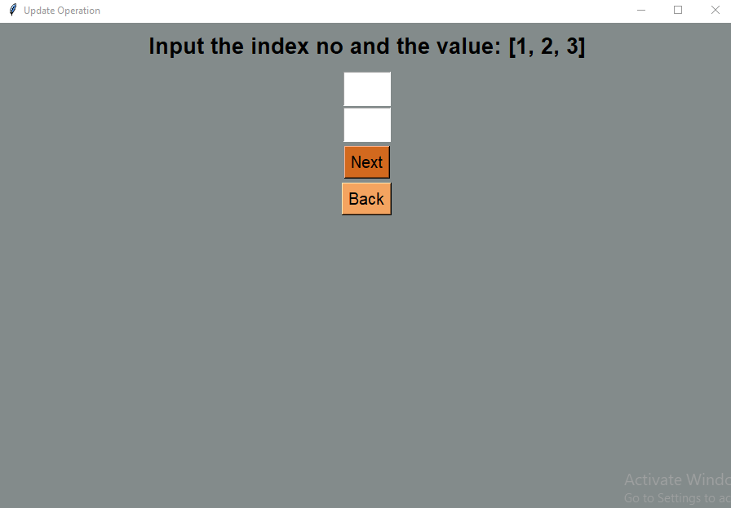

**Linked List:**In the same way if we choose linkedlist than created a (GUI) surface.And than we do the operation like insert , delete , search , and update.The exit button have the down-right corner if you click the button than we exit the (GUI) page.Each node have two part data and another node link address at first enter the value and next enter the node number.If you want the value user enter that value add before the node than **hit** the add before node.If user want this value add at the beginning than **hit** the Add at the beginning.If user want this value add after the node than **hit** the add after node.if user want this value add at the end than **hit** Add at the end button.If you want delete any particular node that input the node number and click the Delete node.when any of operation is done you can click the Display list buttonto see how is the position of linked list.If you want see the previous (GUI) page click the Back button.

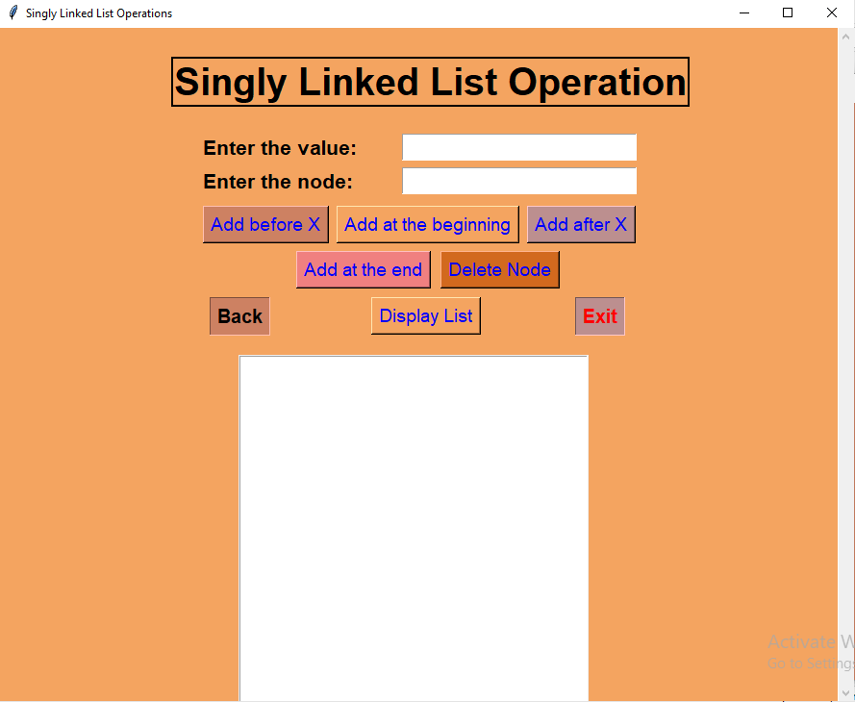

**4.** Dependencies**:**

**Pycharm IDE:** Pycharm is a dedicated python integrated development environment(IDE) providing a wide range of essential tools for python developers , tightly integrated to create a convenient environment for productive python ,web , and data science.

**Python Language:** This project based on python language and we are using (Tkinter) in-built library to create (GUI) surface.

**21 June, 2023**

**North Western University**

**Khulna, Bangladesh**.